Project proposal
Experience/Outcome | Dataset
A clinical decision support dashboard where providers can input patient data and receive real-time risk scores for CRRT filter clotting, along with personalized recommendations and an LLM assistant for explanations. | MIMIC-IV derived dataset  5 CSV files: CRRT parameters, coagulations studies, complete blood counts, chemistry, SOFA scores  Contains patient demographics, lab values, circuit parameters, and filter outcomes
ML + LLM Integration | Anticipated challenges
Supervised learning: Will try Logistic Regression + Random Forest  The LLM layer converts model outputs into a short, clinician-friendly rationale (e.g. Platelets and fibrinogen elevated, INR low high likelihood of clotting)  The LLM will also suggest actionable next steps for providers | - Missing data handling  - Temporal dynamics of lab values  - Class imbalance (clotting vs non-clotting)  - Feature selection from 100s+ potential variables (*will need to research variables more before finalizing dataset)  - Model interpretability for clinical trust  - Dataset(s) size
REFERENCE PROJECT 1  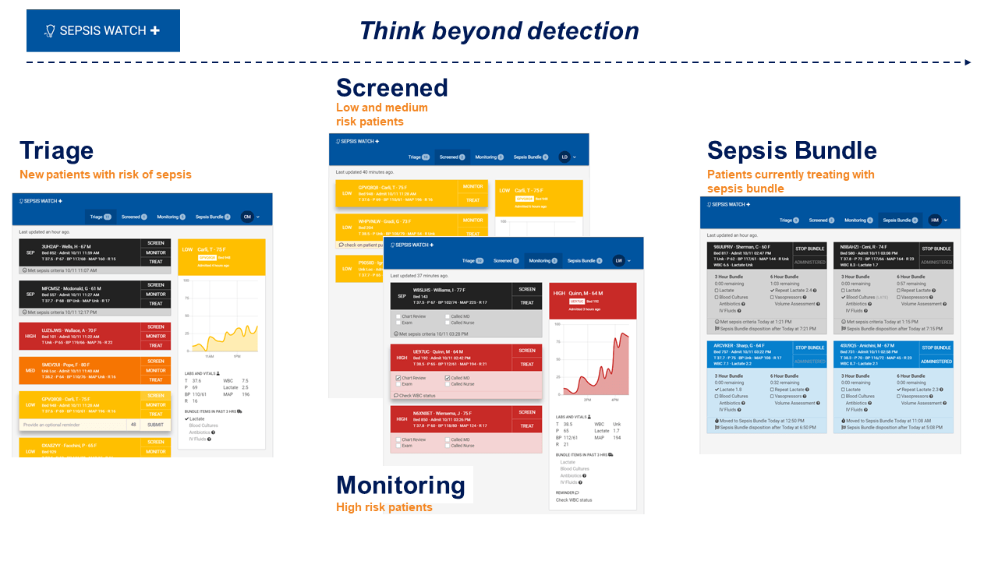  Since our hospital implemented a sepsis MLmodel, I’ve seen firsthand that technical accuracy means nothing without clinical explainability. For example, when patients flag for sepsis, I round with the attending to review the alert. Easily 9/10 times, the provider asks, “Why did this patient trigger?” and we have no clear answer. The model uses ~80 hidden features, so we can’t point to the specific clinical drivers behind the alert. As a result, even though the model is high-performing and tied to CMS measures, providers routinely dismiss it because they don’t understand the reasoning. If the patient doesn’t fit the usual sepsis picture, they don’t adjust care based on a black-box algorithm. This experience reinforced the idea that accuracy alone doesn’t drive adoption, trust does, and trust comes from explainability. That is why I’m hoping this CRRT project will deliver clear, clinically intuitive rationales behind each risk prediction rather than a mystery score. Clinicians should never have to guess why an algorithm is telling them something, and a model that can’t be understood at the bedside simply won’t be used. | REFERENCE PROJECT 2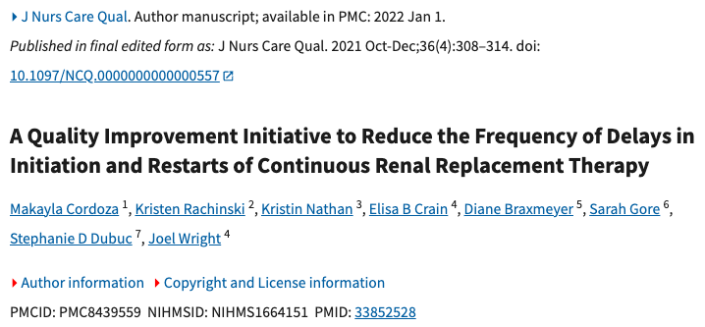  The second reference highlights the patient impact of CRRT interruptions. When a circuit clots, therapy stops immediately, meaning the patient is no longer receiving continuous kidney support during a critical window. Restarting the machine is not fast as it often requires waiting for a dialysis nurse, gathering supplies, priming tubing, and re-establishing the circuit, which can take over an hour. During that time, critically ill patients accumulate fluid, lose metabolic control, and face unnecessary delays in care. For unstable patients, even short gaps in CRRT can worsen acidosis, electrolyte abnormalities, and volume overload. The goal of my project is to prevent avoidable interruptions by identifying clotting risk before the filter fails, ensuring CRRT remains continuous and patients receive the uninterrupted therapy they need to stabilize and recover.
REFERENCE PROJECT 3
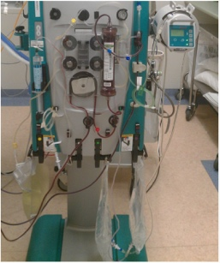

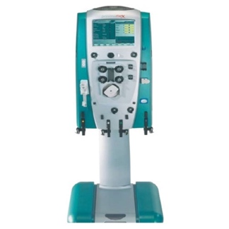
The third reference is the my personal lived experience in working with CRRT, which is what initially inspired this project idea. Restarting a clotted circuit is time-consuming, equipment-heavy, and disrupts care. A full setup involves multiple bags, tubing, priming the machine, and ensuring access lines are functioning. If the bedside nurse isn’t CRRT-trained (majority of nurses are not), then the patient often waits 2+ hours for a dialysis nurse to come, plus the 20–30 minutes required to get the circuit running again. A model that flags clotting risk before it happens directly saves time, reduces interruptions in therapy, supports nurses, and ultimately helps critically ill patients stay on continuous treatment without avoidable downtime.

